Executive Summary
Muffin Maniacs, a rapidly growing bakery chain on the West Coast, faces increasing operational challenges as its workforce expands across multiple storefront and production locations. Employees frequently require timely answers to questions regarding payroll, scheduling, leave policies, benefits, and compliance-related procedures. However, the HR team is not staffed 24/7, leaving overnight employees without immediate access to reliable information. As a result, HR experiences a growing backlog of repetitive inquiries, and employees risk turning to public AI tools to obtain answers—creating serious privacy and security concerns.
The Muffin Mate project addresses these issues by introducing a secure, in-house HR chatbot that uses Retrieval-Augmented Generation (RAG) to deliver accurate, document-grounded responses, available 24 hours a day. Unlike public chatbots, Muffin Mate never sends data outside the company’s protected systems, ensuring regulatory compliance and preventing sensitive information from leaking to third-party providers. By connecting policy queries directly to validated HR documents, the chatbot improves decision-making for employees while reducing manual overhead for HR staff.
This report provides a full overview of the company background, the HR challenges addressed, the system requirements, the RAG-based system architecture, the selected technologies (Ollama, Llama 3, vector storage, authentication tools), the security strategy, and a summary of the functional prototype developed during this project. The final solution positions Muffin Maniacs to enhance internal efficiency, improve employee experience, and adopt modern AI safely and responsibly.

Company Overview
Company Name: Muffin Maniacs
Industry: Specialty bakery with hybrid storefront and ghost-kitchen operations
Muffin Maniacs is a modern bakery known for creative, event-ready muffins with a loyal customer base and an expanding footprint across the West Coast. The business operates a mixture of customer-facing storefronts and kitchen-only locations focused on high-volume production for catering and local stores. Because daily output and order-handling capacity are limited, operational consistency and clear communication are essential for maintaining service quality.
The company’s primary competitor, Cupcake Holics, poses additional pressure for Muffin Maniacs to streamline internal processes and ensure strong employee support systems. Efficient HR communication plays an important role in maintaining staff satisfaction and productivity across multiple shifts and locations.

Problem Statement
Employees often have urgent questions involving policies, pay schedules, benefits, and compliance requirements. However, HR representatives cannot be available around the clock, especially for night-shift workers. This creates multiple issues:
- Delayed Information Access – Employees wait hours or days for answers, slowing decision-making.
- HR Backlog – The HR team is inundated with high-volume, repetitive questions. This consumes valuable time that could be dedicated to more complex, strategic issues like talent acquisition, employee relations, and compliance reporting.
- Lost Productivity – Employees frequently search for outdated or inconsistently stored documents across internal drives.
- Security Risks – Frustrated by the delays, employees are increasingly turning to public AI tools to ask sensitive questions. They might paste in excerpts from a benefits document or describe a specific personal scenario, leading to the inadvertent leakage of confidential company policy and employee data, creating a massive compliance and privacy risk.
Proposed Solution:
An internal secure, in-house HR chatbot - Muffin Mate - that enables employees to easily ask questions and get real-time, accurate answers based on the latest company policies. This system will be available 24/7 and will be directly and securely connected to the company's internal, canonical HR knowledge base (employee handbooks, policy documents, benefits guides). The system ensures privacy, accuracy, and reliability, while allowing HR and IT to update documents in real time.

Requirements and Goals
Functional Requirements
- Natural language understanding for employee HR queries
- Retrieval of relevant HR policies (PDFs, text documents, SharePoint)
- Response citations or policy section links
- Routing of unanswered questions to HR
- Interaction logging for compliance and analytics
- Manager- and HR-specific query permissions
- Support for document downloads (forms, guides, etc.)
- Push reminders for policy changes or payroll updates
Non-Functional Requirements
- Response times within a few seconds for typical queries
- Complies with accessibility standards for employees with disabilities while having an easy-to-use interface that supports text-based interaction
- Maintainability for HR-led document updates
- Scalability to serve concurrent users across multiple locations without performance issues.
- Optional multilingual support for ESL employees
- Encrypted data storage and controlled retention policies for review and auditing purposes while respecting employee privacy
Security, Privacy, and Compliance Goals
- Use of role-based access controls
- Logging aligned with corporate retention policies
- All model inference executed on internal hardware
- Zero transmission of employee data to third-party APIs
- Password enforcement and periodic access reviews

System Architecture Diagram & Explanation
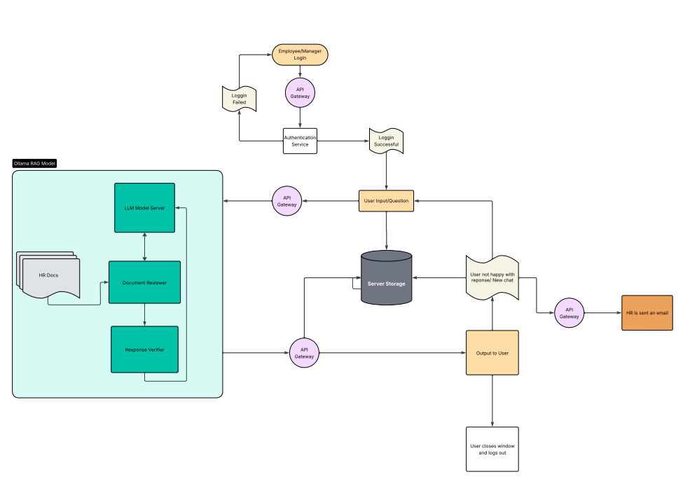

- User Login
Employees or managers authenticate through the company’s internal identity system (e.g., Azure AD). Failed logins loop users back to the login screen. Successful logins redirect to the chat interface.
- Query Submission (Frontend → API Gateway)
The user enters a question. The API Gateway receives the query, checks user role permissions, and forwards it to the RAG system.
- Document Retrieval (Vector Database)
The system identifies the most relevant HR policy passages using embeddings created by HuggingFace MiniLM. These vectors were indexed using the Python script in the prototype.
- LLM Model Server (Ollama + Llama 3)
The retrieved document snippets and user question are sent to the model server, where Llama 3 (running locally in Ollama) generates a grounded, policy-based answer.
- Response Verification
The “Response Verifier” checks that the generated output matches the retrieved text. If insufficient grounding exists, the system flags the answer for HR and withholds low-confidence responses.
- Output to User & Secure Logging
The user receives the verified answer along with citations to policy documents. All interactions are encrypted and logged for compliance and analytics.
If the user is unsatisfied, the system loops them back to the chat interface and notifies HR.

Technology Stack Justification & Security Plan
Technology Stack Justification
1. Ollama – Local Model Hosting
- Provides secure, offline model execution
- Lightweight and fast deployment tool
- Prevents data from leaving the company network
2. Llama 3 – LLM “Brain”
- 8B model provides an optimal balance of speed and accuracy
- 128k context window supports large HR documents
- Efficient enough to run on in-house hardware
3. RAG Pipeline
- Ensures answers are grounded only in approved HR policy documents
- Prevents hallucinations
- Allows immediate policy updates without retraining
4. Python & LlamaIndex
- Simple integration for vector storage, embeddings, and retrieval
5. Authentication & Access Control
- Integrates with existing employee login credentials (e.g., Azure AD)
- Simplifies auditing and reduces risk of account misuse
Security Plan
Key components of the security architecture include:
- Strong Password Policies (enforced at the OS and authentication layer)
- Internal-only hosting of the LLM, vector database, logs, and all HR documents
- Encrypted Log Storage for auditing and compliance
- No external API calls, removing exposure to third-party data harvesting
- Periodic Access Reviews to ensure only appropriate personnel maintain access
- Document-Level Permissions to ensure HR-specific materials are restricted as needed

Prototype Summary
The prototype demonstrates a functional RAG-powered HR question-answering system built using:
- LlamaIndex for vector indexing
- HuggingFace MiniLM embeddings
- Ollama as the model host
- Llama 3 as the inference model
- Local text document ingestion (combined_documents.txt)
Prototype Capabilities
- Loads and indexes internal HR text documents
- Accepts natural language questions through command line and Ollama UI
- Retrieves relevant policy content and generates answers
- Demonstrates proof-of-concept RAG flow
- Supports document updates by modifying the ingestion folder
- Allows for easy expansion into a full web-based interface
How to Run the Prototype
The system can be executed locally following the instructions in the README found https://github.com/cuwilson/Secure-Internal-Chatbot-Design:
- Install Ollama
- Install Python dependencies
- Place HR documents into the .ollama/models/documents directory
- Run rag_demo.py to start the chatbot
- Optionally create a custom model with ollama create muffin-hr

Lessons Learned
- RAG prevents hallucinations more effectively than LLM fine-tuning
Using document retrieval ensures answers match official HR policy and are not fabricated.
- Local hosting dramatically improves security
Keeping all inference internal prevents employee data from being exposed to cloud providers.
- Document formatting matters
Consistent policy formatting enables stronger retrieval accuracy in the vector database.
- Verification layers are essential
Simply retrieving documents is not enough—responses must also be validated to prevent outdated or misaligned answers.
- User expectations vary
Employees expect fast, direct answers, while HR expects accuracy, logging, and compliance. Keeping both those needs in mind shapes how the system is designed.
- Scalability must be planned early
As more policy documents are added, indexing and retrieval performance depend on hardware optimization and good embedding choices.

